Bob The Bear (100 Marks)

Bob is a grizzly bear and just like all grizzlies he loves hunting salmon fish. Bob has a strategy for catching salmons. He stands at the edge of the river and waits for the fishes to cross him. Whenever a fish comes in the same line as that of Bob, he catches it.

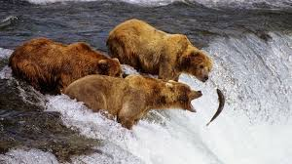

For the sake of the problem assume the river is flowing from **left to right** and Bob is currently sitting at **x-coordinate = 0** (origin). All the fishes are swimming with the river's flow at a uniform speed of **1** from left to right. The x-coordinates increases as we move rightwards in the river and decreases as we move leftwards. **Initially all the fishes has non-positive x-coordinates.**

You are given the information about **N** salmons in two arrays **len** and **time**, where len[i] = length of the ith salmon and time[i] = time at which the head of the ith salmon reaches the x-coordinate = 0 (origin). So, at any time T, the ith salmon  has its head at x-coordinate = T - time[i] and tail at x-coordinate = T - time[i] - len[i].

At any point of time Bob can catch all the salmons whose any part of body (between head and tail, both inclusive) is at origin.

**Bob wants to catch salmons no more than twice**. What is the maximum number of Salmons Bob can catch?

**Input Format**

First line of input contains an integer N representing the number of salmons.

Second line of input contains N space separated integers representing the contents of array **len**.

Third line of input contains N space separated integers representing the contents of array **time**.

The last line of input is kept blank.

**Constraints**

1 <= N <= 1000

1 <= len[i] <= 1000, 000, 000

0 <= time[i] <= 1000, 000, 000

**Output Format**

An integer representing the maximum number of salmons Bob can catch.

**Sample TestCase 1**

Input

5

2 4 4 2 4

1 4 1 6 4

Output

5

Explanation

The situation at time = 0 is shown in the following figure.

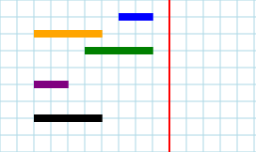

The red line denotes x = 0 (origin) ,Bob is sitting. The blue line shows 1st salmon, the orange one shows 2nd salmon, the green one shows 3rd salmon and so on.

Bob will catch salmon 1 and 3 at time = 2 and will catch salmon 2, 4 and 5 at time = 7.

**Sample TestCase 2**

Input

1

1

2

Output

1

[Sample Problem with Solution](https://www.techgig.com/platform-faq)